Supplementary Table 1: Algal Bioactive Compounds- Source
Bioactive Compound | Representative Source | All Sources
Eckol | 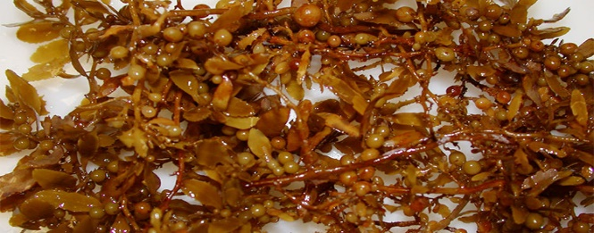  Sargassum | Phlorotannin isolated from Brown algae
Sargafuran | Sargassum | Marine brown algae- Sargassum macrocarpum
Vitamin E  (α-tocopherol) | 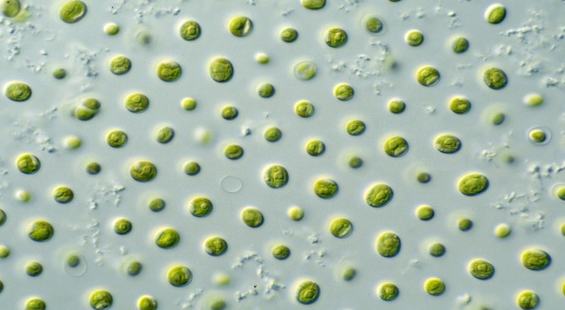  Microalgae | Microalgae (largest amount synthesized by Euglena gracilis cells), other plant sources include olive oil, cocnut oil, kale, broccoli, avocado, almonds
Docosahexaenoic acid | 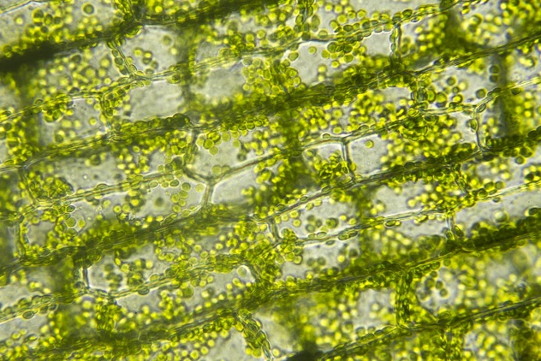  Schizochytrium sp. | Algal oil, other sources include fish (salmon, tuna), trout, mussels, crab
Fucoidan | Brown algae | Brown algae and Brown seaweed
Supplementary Table 2: Prediction of Compounds Bioactivity- PASS
Compound | Bioactivity  (Pa Above 0.7) | Anti-inflammatory
Eckol | Membrane integrity agonist, Chlordecone reductase inhibitor, Antioxidant, Membrane permeability inhibitor, HIF1A expression inhibitor, Aspulvinone dimethylallyltransferase inhibitor, JAK2 expression inhibitor, Antiseborrheic, Ubiquinol-cytochrome-c reductase inhibitor, 2-Dehydropantoate 2-reductase inhibitor, Peroxidase inhibitor, Kinase inhibitor, NADPH-cytochrome-c2 reductase inhibitor, MAP kinase stimulant, Histidine kinase inhibitor, Antihemorrhagic, CYP2C12 substrate, Mucomembranous protector, APOA1 expression enhancer, NADPH peroxidase inhibitor, Hepatic disorders treatment, Aryl-alcohol dehydrogenase (NADP+) inhibitor, NADPH-ferrihemoprotein reductase inhibitor, P-benzo quinone reductase (NADPH) inhibitor,Dehydro-L-gulonate decarboxylase inhibitor, Feruloyl esterase inhibitor, Sugar-phosphatase inhibitor, Testosterone 17ß -dehydrogenase (NADP+) inhibitor | 0.862
Sargafuran | Prenyl-diphosphatase inhibitor, Lipid metabolism regulator, Mucomembranous protector, Undecaprenyl-phosphate mannosyl transferase inhibitor, Antineoplastic, Free radical scavenger | 0.406
Docosahexaenoic acid | CYP2J2 substrate, Antieczematic, Linoleate diol synthase inhibitor, Alcohol O-acetyltransferase inhibitor, Lipid metabolism regulator, Phosphatidylglycerophosphatase inhibitor, Acylcarnitine hydrolase inhibitor, Mucomembranous protector, Alkylacetylglycero phosphatase inhibitor, Alkenylglycerophosphocholine hydrolase inhibitor, Chymosin inhibitor, Saccharopepsin inhibitor, Acrocylindropepsin inhibitor, Lipoprotein lipase inhibitor, Methylamine-glutamate N-methyltransferase inhibitor, Carboxypeptidase Taq inhibitor, All-trans-retinyl-palmitate hydrolase inhibitor, Dextranase inhibitor, GST A substrate, Phosphatidylcholine-retinol O-acyltransferase inhibitor, G-protein-coupled receptor kinase inhibitor, ß -adrenergic receptor kinase inhibitor, Fatty-acyl-CoA synthase inhibitor, Phobic disorders treatment, Macrophage colony stimulating factor agonist, CYP4A11 substrate, Sugar-phosphatase inhibitor, Prostaglandin-E2 9-reductase inhibitor, Pro-opiomelanocortin converting enzyme inhibitor, Pullulanase inhibitor, Polyporopepsin inhibitor, Sarcosine oxidase inhibitor, Methylenetetrahydrofolate reductase (NADPH) inhibitor, Leukotriene-B4 20-monooxygenase inhibitor, Aspartate-ammonia ligase inhibitor, Poly(alpha-L-guluronate) lyase inhibitor, Sphinganine kinase inhibitor, Chlordecone reductase inhibitor, Exoribonuclease II inhibitor, Testosterone 17ß -dehydrogenase (NADP+) inhibitor, Glucan endo-1,3-ß -D-glucosidase inhibitor, Ethanolamine-phosphate cytidylyltransferase inhibitor, N-(long-chain-acyl)ethanolamine deacylase inhibitor, CYP4A2 substrate, CYP2E1 inhibitor, Xylan endo-1,3-ß -xylosidase inhibitor, Glutarate-semialdehyde dehydrogenase inhibitor, Prostaglandin-A1 DELTA-isomerase inhibitor, N-formyl methionyl-peptidase inhibitor, Dimethylargininase inhibitor, Poly(ß -D-mannuronate) lyase inhibitor, Cholesterol antagonist, Plasmanylethanolamine desaturase inhibitor, Protein-disulfide reductase (glutathione) inhibitor, Antimutagenic,15-Hydroxyprostaglandin-D dehydrogenase (NADP+) inhibitor, L-glucuronate reductase inhibitor, Angiogenesis stimulant, Antiinflammatory, Cl--transporting ATPase inhibitor, Aspulvinone dimethylallyltransferase inhibitor, Ubiquinol-cytochrome-c reductase inhibitor, Arginine 2-monooxygenase inhibitor, BRAF expression inhibitor, Lysine 2,3-aminomutase inhibitor, Oxidoreductase inhibitor, Gluconate 5-dehydrogenase inhibitor, Fragilysin inhibitor, D-lactaldehyde dehydrogenase inhibitor, Antihypercholesterolemic, Linoleate isomerase inhibitor, Alcohol dehydrogenase (NADP+) inhibitor, Pectin lyase inhibitor, Peptide-N4-(N-acetyl-ß -glucosaminyl) asparagine amidase inhibitor, NADPH-cytochrome-c2 reductase inhibitor, Creatininase inhibitor, HMOX1 expression enhancer, Fusarinine-C ornithinesterase inhibitor  CYP4A substrate, Platelet aggregation stimulant, Cyclooxygenase 1 substrate, Feruloyl esterase inhibitor, Glycosylphosphatidylinositol phospholipase D inhibitor, Vasoprotector, Allyl-alcohol dehydrogenase inhibitor, Phenylacetate-CoA ligase inhibitor, Electron-transferring-flavoprotein dehydrogenase inhibitor, Fucosterol-epoxide lyase inhibitor, Levanase inhibitor, Gluconate 2-dehydrogenase (acceptor) inhibitor, Lysostaphin inhibitor,  Thromboxane synthase stimulant, Antiseborrheic, Phenol O-methyltransferase inhibitor, Biliary tract disorders treatment, NADH kinase inhibitor, 1,4-Lactonase inhibitor, CYP3A1 substrate, NADPH peroxidase inhibitor, Glutamyl endopeptidase II inhibitor, Ecdysone 20-monooxygenase inhibitor, Membrane integrity agonist, Uroporphyrinogen decarboxylase inhibitor, Ribulose-phosphate 3-epimerase inhibitor, GABA aminotransferase inhibitor, UGT2B1 substrate, 5-O-(4-coumaroyl)-D-quinate 3'-monooxygenase inhibitor, Pseudolysin inhibitor, Glutamine-phenylpyruvate transaminase inhibitor, 2-Haloacid dehalogenase (configuration-inverting) inhibitor, Alkenylglycerophospho ethanolamine hydrolase inhibitor, Acetylesterase inhibitor, Polyamine-transporting ATPase inhibitor, Phosphatidate phosphatase inhibitor, Creatinase inhibitor, 2-Oxoglutarate decarboxylase inhibitor, IgA-specific metalloendopeptidase inhibitor, Protein-tyrosine sulfotransferase inhibitor, Arachidonate-CoA ligase inhibitor, Glucan 1,4-alpha-maltotriohydrolase inhibitor, Amino carboxy muconate-semialdehyde decarboxylase inhibitor, 3-Phytase inhibitor, 4-Hydroxy glutamate transaminase inhibitor, Endo cannabinoid uptake inhibitor, Nitrite reductase (NO-forming) inhibitor, Peroxidase substrate, Lactase inhibitor, Tpr proteinase (Porphyromonas gingivalis) inhibitor, Antisecretoric, Adenomatous polyposis treatment, 2,3,4,5-Tetrahydropyridine-2,6-dicarboxylate N-succinyl transferase inhibitor, Formaldehyde transketolase inhibitor, Omptin inhibitor, Venombin AB inhibitor, 2-Hydroxyquinoline 8-monooxygenase inhibitor, Methylumbelliferyl-acetate deacetylase inhibitor, Shikimate O-hydroxycinnamoyl transferase inhibitor, Phosphoenolpyruvate-protein phosphotransferase inhibitor, Peptidoglycan glycosyltransferase inhibitor, 3-Oxoadipate enol-lactonase inhibitor, Peptidyl-dipeptidase Dcp inhibitor, Vitamin-K-epoxide reductase (warfarin-insensitive) inhibitor, Phosphoinositide 5-phosphatase inhibitor, Platelet adhesion inhibitor, Arylmalonate decarboxylase inhibitor, Vanilloid 1 agonist, Prostaglandin E1 antagonist, 2-Hydroxy-3-oxoadipate synthase inhibitor, Phthalate 4,5-dioxygenase inhibitor, Antithrombotic, Phosphatidylinositol diacylglycerol-lyase inhibitor, UDP-N-acetylglucosamine 4-epimerase inhibitor, 1-Alkylglycero phosphocholine O-acetyltransferase inhibitor, Mucositis treatment, CYP2C substrate, Reductant, Proteasome ATPase inhibitor, Biotinidase inhibitor, Di-trans,poly-cis-decaprenylcistransferase inhibitor, Glucan 1,4-alpha-maltotetraohydrolase inhibitor, Glyoxylate reductase inhibitor, Benzoate-CoA ligase inhibitor, Leukopoiesis stimulant, Methanol dehydrogenase inhibitor, Dolichyl-phosphatase inhibitor, Dehydro-L-gulonate decarboxylase inhibitor, Glucose oxidase inhibitor, Myosin-light-chain-phosphatase inhibitor, Monodehydroascorbate reductase (NADH) inhibitor, Endopeptidase So inhibitor, ADP-thymidine kinase inhibitor, Fumarate reductase (NADH) inhibitor, Mannitol-1-phosphatase inhibitor, Cyclo oxygenase substrate, Gluconolactonase inhibitor, Preneoplastic conditions treatment, Prenyl-diphosphatase inhibitor, Superoxide dismutase inhibitor, Sulfite reductase inhibitor, TP53 expression enhancer, Gastrin inhibitor, Arylsulfate sulfotransferase inhibitor, Protein-glutamate methylesterase inhibitor, 2-Methyleneglutarate mutase inhibitor, Undecaprenyldiphospho-muramoylpentapeptide ß -N-acetylglucosaminyltransferase inhibitor, TNF expression inhibitor, Hydrogen dehydrogenase inhibitor, Aspartate-phenylpyruvate transaminase inhibitor, CYP2C8 inhibitor, Tryptophanamidase inhibitor, CYP2C8 substrate, Eye irritation, inactive, Phosphatidylserine decarboxylase inhibitor, Taurine dehydrogenase inhibitor, Membrane permeability inhibitor | 0.819
Fucoidan | Benzoate-CoA ligase inhibitor, Sugar-phosphatase inhibitor, G-protein-coupled receptor kinase inhibitor, ß -adrenergic receptor kinase inhibitor, Coenzyme-B sulfoethylthio transferase inhibitor, Exoribonuclease II inhibitor, CYP2C12 substrate, IgA-specific metallo endopeptidase inhibitor, Glucan 1,4-alpha-maltotriohydrolase inhibitor, Pullulanase inhibitor, Urethanase inhibitor, Anthranilate-CoA ligase inhibitor, Levanase inhibitor, Glucan endo-1,3-ß -D-glucosidase inhibitor, Alkylacetyl glycerol phosphatase inhibitor, ß -mannosidase inhibitor, L-iduronidase inhibitor, Endoglycosylceramidase inhibitor, Dextranase inhibitor, Cyclomaltodextrinase inhibitor, Peptide-N4-(N-acetyl-ß -glucosaminyl) asparagine amidase inhibitor, Licheninase inhibitor, Protein-Npi-phosphohistidine-sugar phosphotransferase inhibitor, Lysine 2,3-aminomutase inhibitor, Antibiotic Glycopeptide-like CDP-glycerol glycerophosphotransferase inhibitor, Poly poropepsin inhibitor, Cholesterol antagonist, SULT1E1 substrate, Arylsulfate sulfotransferase inhibitor, Phenylacetate-CoA ligase inhibitor, Fibroblast growth factor 2 antagonist, Alpha-L-rhamnosidase inhibitor, Mannosyl-glycoprotein endo-ß -N-acetylglucosaminidase inhibitor, IgA-specific serine endopeptidase inhibitor, CYP2H substrate, Alkenylglycerophosphocholine hydrolase inhibitor, Alternansucrase inhibitor, D-lactaldehyde dehydrogenase inhibitor, Hydroxylamine reductase (NADH) inhibitor, Adenomatous polyposis treatment, Carboxypeptidase Taq inhibitor, Galactolipase inhibitor, Vasoprotector, Membrane permeability inhibitor, Antiviral (Rhinovirus), Biliary tract disorders treatment, Acute neurologic disorders treatment, Alpha-N-arabino furanosidase inhibitor, Dextransucrase inhibitor, Cellulase inhibitor, 1,2-alpha-L-fucosidase inhibitor, Serine-sulfate ammonia-lyase inhibitor, Gluconate 5-dehydrogenase inhibitor, Glutathione S-transferase substrate, Sclerosant,  Xylan endo-1,3-ß -xylosidase inhibitor, Glucan endo-1,6-ß -glucosidase inhibitor, Pseudolysin inhibitor, Glucan 1,4-ß glucosidase inhibitor, Chitinase inhibitor, Hemostatic, UDP-N-acetylglucosamine 4-epimerase inhibitor, Glycopeptide alpha-N-acetylgalactosaminidase inhibitor, Glyceryl-ether monooxygenase inhibitor, Ubiquinol-cytochrome-c reductase inhibitor | 0.635
Vitamin E  (α-tocopherol) | Lipid peroxidase inhibitor, Antioxidant, CYP2C12 substrate, Acute neurologic disorders treatment, Antihypercholesterolemic, Antiischemic, cerebral, Reductant, AR expression inhibitor, Hypolipemic, Male reproductive disfunction treatment Nucleotide metabolism regulator, Prion diseases treatment, Antiinflammatory, Cholesterol antagonist, Anticataract, CYP2C19 substrate, CYP2E substrate, CYP2E1 substrate, CYP2C substrate, CYP2C8 inhibitor, CYP2C8 substrate, Ubiquinol-cytochrome-c reductase inhibitor, Apoptosis agonist, Vitamin, Glycogen synthase stimulant, Antianginal, Testosterone 17ß -dehydrogenase (NADP+) inhibitor,TP53 expression enhancer | 0.814
Elagolix | - | -

